UBND THÀNH PHỐ HỒ CHÍ MINH | CỘNG HÒA XÃ HỘI CHỦ NGHĨA VIỆT NAM
TRƯỜNG CAO ĐẲNG LÝ TỰ TRỌNG | Độc lập - Tự do - Hạnh phúc
THÀNH PHỐ HỒ CHÍ MINH
ĐỀ THI KẾT THÚC HỌC PHẦN LÝ THUYẾT
HỌC KỲ: II NĂM HỌC: 2019 – 2020
Bậc đào tạo: CAO ĐẲNG (C1)
Học phần: TIẾNG ANH 1
Lớp: 19C1-_________ Ngày thi: _______ / _______ / 2020
Thời gian thi: 60 phút (không kể thời gian phát đề)

Thí sinh không được sử dụng tài liệu, nộp lại đề sau khi thi
Mã đề 101

Bài thi này gồm 50 câu, mỗi câu 0.2 điểm.

Multiple-choice
1/ Our ____ is 72 Grant Avenue.
a number b sign c address d road
2/ - How ___? - I'm twenty.
a old you are b old are you c you are old d are you
3/ James is from England. ___ wife is from USA.
a Our b His c My d Their
4/ That is my father's dog. ____ ears are very big.
a Its b Its' c It's d Both a&b are correct.
5/ Excuse ____, we have a problem. Can you help ____?
a me/ me b you/ me c me/ our d me/ us
6/ All the ___ clothes are wet from the rain.
a boys' b boys c boyes’ d boy'es
7/ Choose the word that is different.
a second b three c one d two
8/ We live in America ___ we have a big family.
a because b and c despite d None is correct.
9/ I have some pictures ___ my phone.
a at b to c on d All are correct.
10/ I have some pictures. Here, ___ a look.
a put b take c give d work
11/ Austrians work ___ hours than people in other countries.
a fewer b much c less d least
12/ In the USA, there is no paid time off ___.
a accountant b relaxing c search d requirement
13/ 1 ___4 Americans don't get any paid time off of work.
a on b to c at d in
14/ Austria has a good vacation time ___ and fewer ____ hours.
a average/ to work b requirements/ works
c policy/ working d choice/ work
15/ She did some ____ at home yesterday.
a errands b choice c vacation d average
16/ It was a ____ trip.
a relaxing b relax c relaxed d All are correct.
17/ The sofa is in the ___.
a wall b floor c corner d two chairs
18/ Our office has a green sofa in the ___.
a mirror b bedroom c waiting room d bathroom
19/ I'm late ___ work.
a in b for c on d at
20/ What do you always do first ___ you come home?
a because b while c what d when
21/ Put the ____ over the table.
a plate b couch c glass d tablecloth
22/ A(n) ___ house uses too many resources.
a big b small c tiny d Both b&c are correct.
23/ There is a family in Virginia ___ built a tiny house.
a whom b whose c which d who
24/ We usually take a shower in the ____.
a living room b bedroom c dining room d bathroom
25/ Are ____ tomatoes in the refrigerator?
a they some b there some c there any d Both a&b are correct.
26/ Do we need ___ mushrooms for this recipe?
a any b much c some d All are correct.
27/ I need a ___ of bread for breakfast.
a piece b slice c loaf d All are correct.
28/ I'm ____! Can we have hamburgers for dinner?
a thirsty b full c recipe d starved
29/ I love mushrooms ___ my hamburgers!
a on b in c at d over
30/ The first recorded sandwich was made by a famous ___.
a writer b rabbi c gravy d Both a&b are correct.
31/ Hillel's Sandwich can be eaten as a part of the ___ Seder.
a Spring Festival b Passover c Thanksgiving d Halloween
32/ Nacho didn't have salad ____ lunch.
a in b for c to d All are correct.
33/ He ___ back tomorrow.
a comes b is coming c come d Both a&b are correct.
34/ I'm eating lunch ___.
a right now b sometimes c already d ago
35/ She ___ a bird now.
a is seeing b sees c saw d see
36/ The politician made a(n) ___ to the people to cut taxes.
a arrange b appointment c punish d promise
37/ I ___ play in the park when I was young.
a got used to b used to c get used to d am used to
38/ I want ___ to the moon some day.
a travel b to travel c to travelling d travelling
39/ She asked her husband to stop ___.
a smokes b to smoking c smoke d smoking
40/ Janet spent $200 ___ a new cell phone.
a buying b buy c to buying d to buy
41/ Last weekend, we went horseback ___ on the farm.
a ridden b rode c ride d riding
42/ Several students from the suburbs ___ buses to school.
a taking b take c get on d getting on

Questions 43 through 46 refer to the following letter.
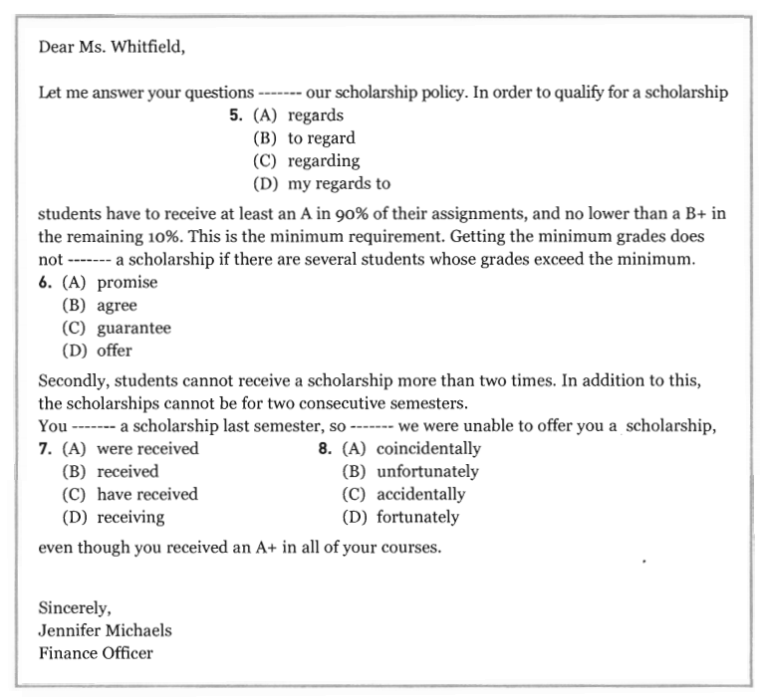
43.
44.
45.
46.

Questions 47 through 50 refer to the following letter.
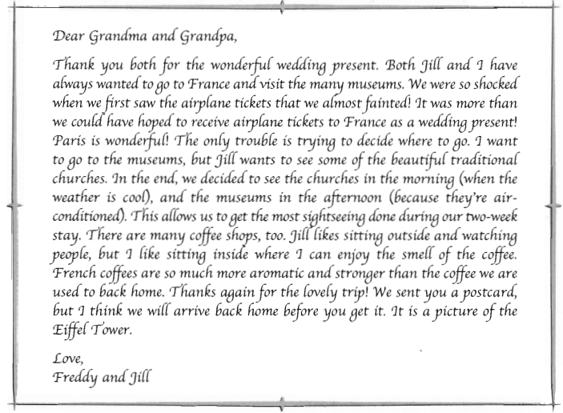
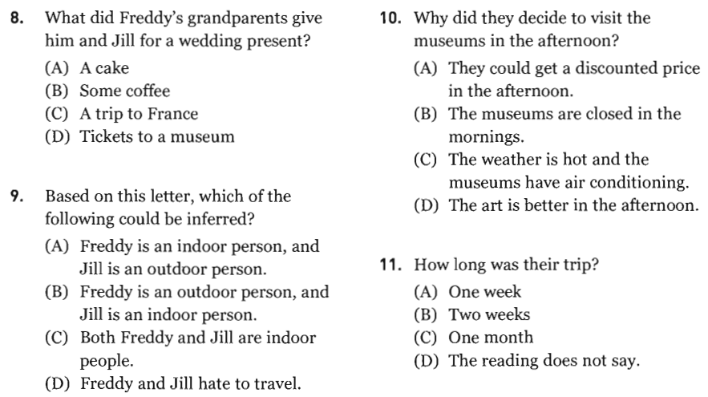
50.
49.
48.
47.
_______Hết_______

GHI CHÚ: CÁN BỘ COI THI KHÔNG ĐƯỢC GIẢI THÍCH GÌ THÊM.

TRƯỞNG KHOA TRƯỞNG BỘ MÔN GIẢNG VIÊN RA ĐỀ
(Ký tên và ghi rõ họ tên) (Ký tên và ghi rõ họ tên) (Ký tên và ghi rõ họ tên)

UBND THÀNH PHỐ HỒ CHÍ MINH | CỘNG HÒA XÃ HỘI CHỦ NGHĨA VIỆT NAM
TRƯỜNG CAO ĐẲNG LÝ TỰ TRỌNG | Độc lập - Tự do - Hạnh phúc
THÀNH PHỐ HỒ CHÍ MINH
ĐỀ THI KẾT THÚC HỌC PHẦN LÝ THUYẾT
HỌC KỲ: II NĂM HỌC: 2019 – 2020

Bậc đào tạo: CAO ĐẲNG (C1)
Học phần: TIẾNG ANH 1
Lớp: 19C1-_________ Ngày thi: _______ / _______ / 2020
Thời gian thi: 60 phút (không kể thời gian phát đề)
Mã đề 102

Thí sinh không được sử dụng tài liệu, nộp lại đề sau khi thi
Bài thi này gồm 50 câu, mỗi câu 0.2 điểm.

Multiple-choice
1/ I ___ a movie last week with my family.
a saw b watch c look d see
2/ We ___ a good ___ at the lake last summer.
a have/ funny b did/ fun c got/ flies d had/ time
3/ He didn't ___ dinner at home. He ___ dinner at a restaurant.
a has/ had b have/ have c have/ had d has/ has
4/ They made pies ___ my birthday.
a in b for c to d at
5/ I had ____ at all the photos from her vacation.
a had b have c to look d None is correct.
6/ Should ____ give workers vacation time?
a employments b employees c employer d employers
7/ Vacations help workers perform ___ at work.
a fewer b badder c better d All are correct.
8/ That restaurant didn't accept _____cards.
a credit b choice c errand d pie
9/ We need two ___ tomatoes for the sauce.
a some b more c few d Both a&b are correct.
10/ I need two ___ of ground beef and ___ mushrooms.
a kilos/ a few b pounds/ some c pounds/ three d All are correct.
11/ I think that ___ going to close.
a storms' b restaurant's c stamp's d restaurant
12/ Mary has ___ money.
a a lot of b a lot c much d Both a&c are correct.
13/ Choose the word that is different.
a potato chips b potatoes c mushrooms d carrots
14/ How many ____ of ____can you sell a day?
a boxes/ cookie b boxes/ cookies c box/ cookies d Both a&b are correct.
15/ - How much bread do you eat a day? - ____.
a A lot b Many c Very much d Both a&c are correct.
16/ They are going ___ a nice meal in restaurant.
a to having b having c have d to have
17/ Mr. Gray sometimes ___ tennis.
a has played b plays c is playing d play
18/ She ___ on the phone when I came in.
a had been talking b was talking c has been talking d Both a&b are correct.
19/ Please ___ John Fisher in the payroll office if you cannot attend.
a talk b speak c repeat d notify
20/ I ___ a shower when the phone rang.
a am taking b took c was taking d take
21/ He ___ money from me three days ago.
a has borrowed b borrows c borrowed d had borrowed
22/ She always ___ the expensive shoes.
a tries b tries on c had tried d trying on
23/ You ___ not come to your appointment on January 5.
a had b are c were d did
24/ I want ___ to the moon some day.
a travelling b to travelling c travel d to travel
25/ I am interested in ___ to France.
a travel b travels c travelling d to travel
26/ Several students from the suburbs ___ buses to school.
a taking b take c get on d getting on
27/ Would you like to meet Mehta? He's my ___.
a cousin b grandmother c aunt d niece
28/ Lois and Bob are my ___. Bob is my mother's father.
a cousins b children c grandparents d parents
29/ Have you met my grandmother? She's my ____.
a father's mother b grandparent c mother's mother d All are correct.
30/ Mary, my ____, lives in a big city far away from us.
a uncle b nephew c grandfather d aunt
31/ ___ sister goes to school in Boston.
a Hana's b Hanas c Hanas' d Both a&c are correct.
32/ Choose the word that is different.
a twelfth b first c seven d third
33/ Our house isn't ___ for everyone.
a bigger b enough big c big enough d All are correct.
34/ Our house is small so I have to ___ a room with my brother.
a share b lost c add d buy
35/ The green apple is ____ the computer.
a between b in c next to d None is correct.
36/ I ___ the door and come inside.
a unclock b unlock c clock d All are correct.
37/ There are some ____ in the living room.
a bookshelfs b cupboard c armchairs d None is correct.
38/ There ___ a bedroom.
a isn't b are c is any d All are correct.
39/ Can you get my ID card? It's ___ my wallet.
a at b in c on d to
40/ A small house uses ___ materials and creates ___ waste.
a less/ fewer b fewer/ fewer c less/ less d fewer/ less
41/ The house is only one hundred and sixty eight ___ feet.
a square b meter c squat d Both a&c are correct.
42/ We usually ____ in the kitchen.
a go beds b built computers c have a shower d make lunch

Questions 43 through 46 refer to the following article.
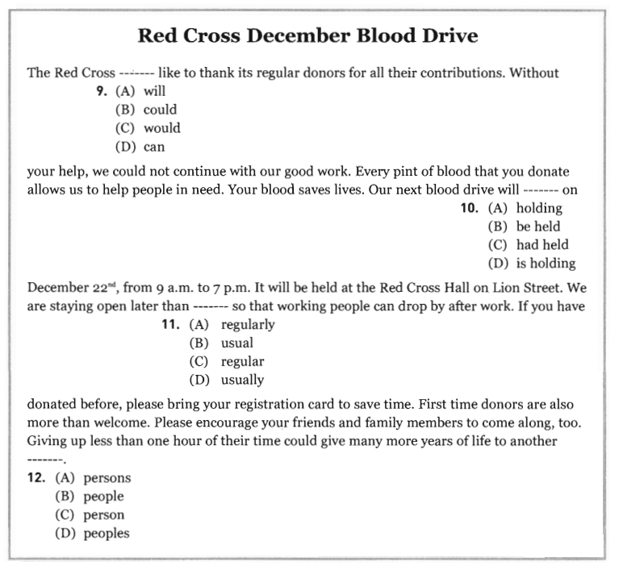
45.
45.
44.
43.

Questions 47 through 50 refer to the following article.
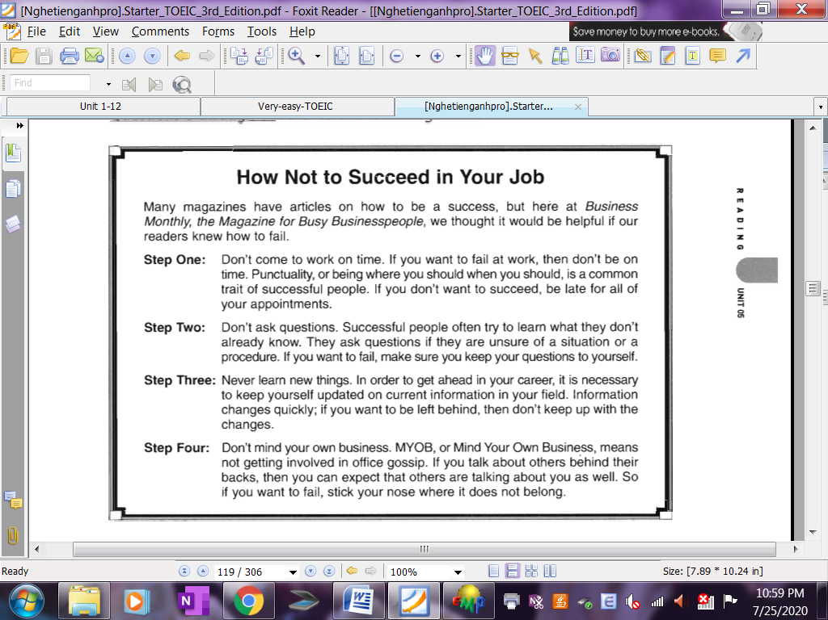

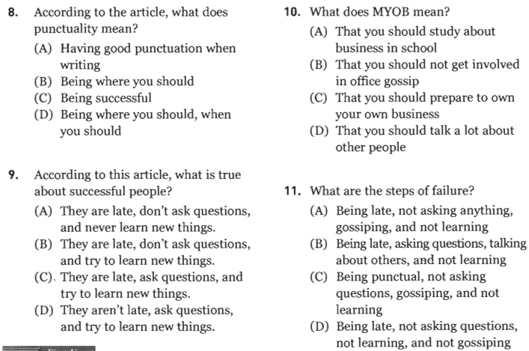
50.
49.
47.
48.
_______Hết_______

GHI CHÚ: CÁN BỘ COI THI KHÔNG ĐƯỢC GIẢI THÍCH GÌ THÊM.

TRƯỞNG KHOA TRƯỞNG BỘ MÔN GIẢNG VIÊN RA ĐỀ
(Ký tên và ghi rõ họ tên) (Ký tên và ghi rõ họ tên) (Ký tên và ghi rõ họ tên)
UBND THÀNH PHỐ HỒ CHÍ MINH | CỘNG HÒA XÃ HỘI CHỦ NGHĨA VIỆT NAM
TRƯỜNG CAO ĐẲNG LÝ TỰ TRỌNG | Độc lập - Tự do - Hạnh phúc
THÀNH PHỐ HỒ CHÍ MINH
ĐỀ THI KẾT THÚC HỌC PHẦN LÝ THUYẾT
HỌC KỲ: II NĂM HỌC: 2019 – 2020
Bậc đào tạo: CAO ĐẲNG (C1)
Học phần: TIẾNG ANH 1
Lớp: 19C1-_________ Ngày thi: _______ / _______ / 2020
Thời gian thi: 60 phút (không kể thời gian phát đề)

Thí sinh không được sử dụng tài liệu, nộp lại đề sau khi thi
Mã đề 103

Bài thi này gồm 50 câu, mỗi câu 0.2 điểm.

Multiple-choice
1/ I'm my mother's ___.
a niece b daughter c sister d aunt
2/ Juanita and Nilo have three ___.
a parent b childs c family d children
3/ Lois and Bob are my ___. Bob is my mother's father.
a parents b grandparents c cousins d children
4/ My three cousins are my ____ children.
a uncle's b aunt's c sister's d Both a & b are correct.
5/ Your grandfather's daughter is your ___.
a mother b sister c aunt d Both a&c are correct.
6/ They're ___ the room number 12 ___ the hotel.
a at/ on b in/ on c on/ in d in/ at
7/ All the ___ clothes are wet from the rain.
a boy'es b boys' c boys d boyes
8/ We live in America ___ we have a big family.
a despite b because c and d None is correct.
9/ There was ____ bread in the cupboard.
a a little b some c any d Both a&b are correct.
10/ Would you like a ___ of cheese?
a pint b piece c bottle d little
11/ I need a ___ of bread for breakfast.
a piece b loaf c slice d All are correct.
12/ I'm ____! Can we have hamburgers for dinner?
a recipe b starved c thirsty d full
13/ The first recorded sandwich was made by a famous ___.
a writer b rabbi c gravy d Both a&b are correct.
14/ He put herbs, apples, and ___ nuts between two pieces of matzo.
a chopped b chops c chop d chopping
15/ People used thick pieces of stale bread instead ____ plates.
a at b in c of d on
16/ He doesn't put ___ salt on his food.
a some b many c much d a
17/ The chairs are next to the big table in the ___.
a office b dining room c staff d Both a&b are correct.
18/ There are keys ___ the bowl ___ to the lamp.
a on/ front b in/ next c in/ on d on/ next
19/ She ___ her keys on the table.
a make b put c lock d take
20/ I ___ the door and come inside.
a unlock b unclock c clock d All are correct.
21/ I'm interested ____ the apartments ___ rent.
a at/ for b to/ in c to/ to d in/ for
22/ How _____bedrooms are there?
a many b much c about d any
23/ That's OK. I think it's perfect ____ us.
a to b at c on d for
24/ There aren't ___.
a some tables b any tables c any table d Both a&b are correct.
25/ She ___ a bird now.
a sees b is seeing c see d saw
26/ She ___ at 123 Main Street.
a live b lives c living d Both a&b are correct.
27/ The baby has been ___ all day.
a cry b crying c cried d to cry
28/ What ___ you ___ at school tomorrow?
a are/ studying b do/ studying c do/ study d Both a&c are correct.
29/ Father is ___ at the movie.
a laughing b been laughing c laughs d laugh
30/ Our family ___ in this city for twenty years.
a has lived b is living c having live d live
31/ George ____ some money from the bank.
a lent b borrowed c borrow d lend
32/ You ___ not come to your appointment on January 5.
a were b did c are d had
33/ I look ___ to hearing from you soon.
a without b before c after d forward
34/ They look forward ___ their son next month.
a to seeing b see c to see d sees
35/ My brother and I went to a baseball ___.
a win b track c sport d game
36/ What ___ you ___ last weekend?
a do/ do b did/ did c do/ did d did/ do
37/ He didn't ___ dinner at home. He ___ dinner at a restaurant.
a have/ had b has/ has c have/ have d has/ had
38/ She went to Thailand two weeks ___.
a yet b ago c just d lately
39/ Where did you ____ a movie?
a see b saw c go d went
40/ - What did Mike ___ yesterday? - He ___ dinner for his family.
a did/ did b do/ made c does/ did d make/ make
41/ You should consider moving to a country with ____.
a fewer working hours b lots of requirements
c a good vacation time policy d Both a&c are correct.
42/ She did some ____ at home yesterday.
a vacation b choice c errands d average

Questions 43 through 46 refer to the following information.
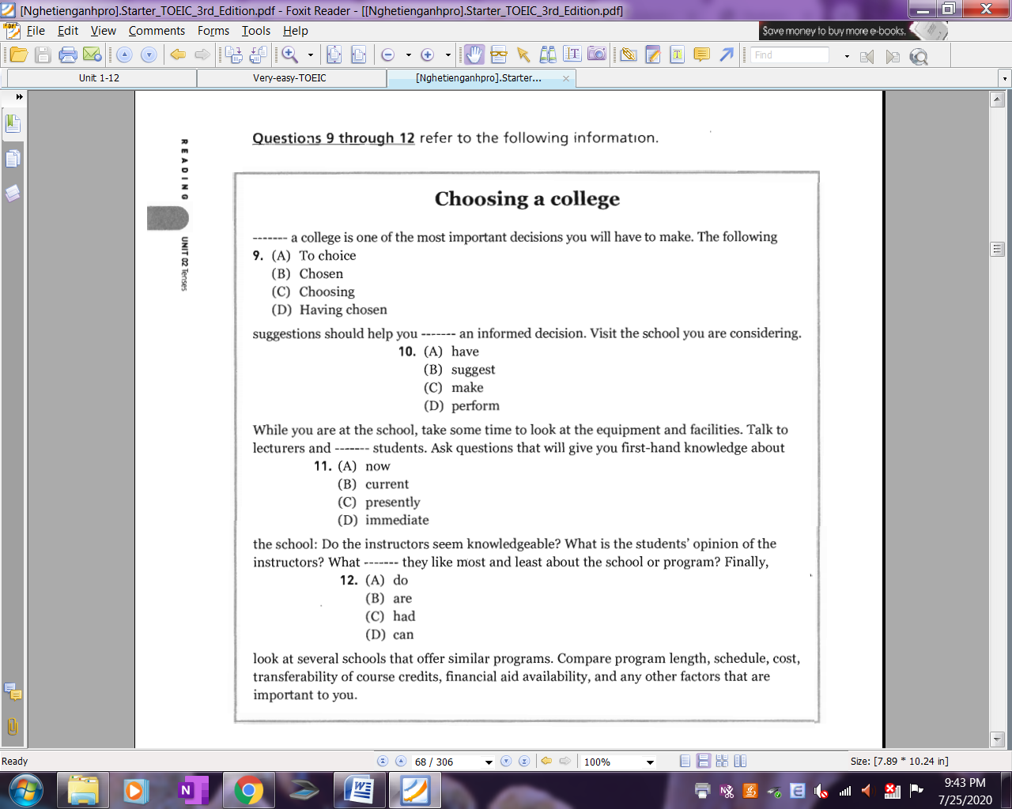
45.
46.
44.
43.

Questions 47 through 50 refer to the following article.
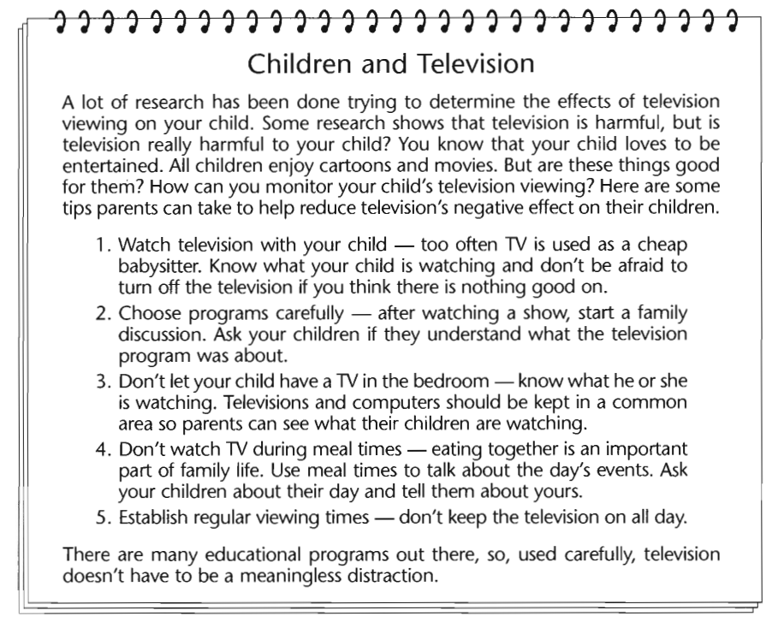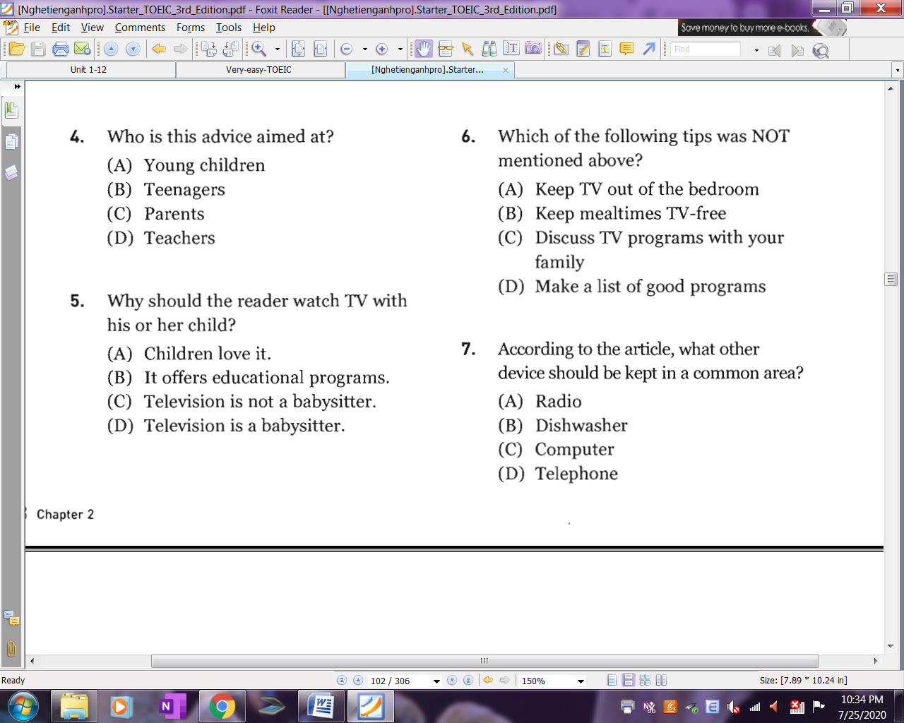
50.
49.
48.
47.
_______Hết_______

GHI CHÚ: CÁN BỘ COI THI KHÔNG ĐƯỢC GIẢI THÍCH GÌ THÊM.

TRƯỞNG KHOA TRƯỞNG BỘ MÔN GIẢNG VIÊN RA ĐỀ
(Ký tên và ghi rõ họ tên) (Ký tên và ghi rõ họ tên) (Ký tên và ghi rõ họ tên)

UBND THÀNH PHỐ HỒ CHÍ MINH | CỘNG HÒA XÃ HỘI CHỦ NGHĨA VIỆT NAM
TRƯỜNG CAO ĐẲNG LÝ TỰ TRỌNG | Độc lập - Tự do - Hạnh phúc
THÀNH PHỐ HỒ CHÍ MINH
ĐỀ THI KẾT THÚC HỌC PHẦN LÝ THUYẾT
HỌC KỲ: II NĂM HỌC: 2019 – 2020
Bậc đào tạo: CAO ĐẲNG (C1)
Học phần: TIẾNG ANH 1
Lớp: 19C1-_________ Ngày thi: _______ / _______ / 2020
Thời gian thi: 60 phút (không kể thời gian phát đề)

Thí sinh không được sử dụng tài liệu, nộp lại đề sau khi thi
Mã đề 104

Bài thi này gồm 50 câu, mỗi câu 0.2 điểm.

Multiple-choice
1/ I usually ___ up at 7:00 in the morning.
a got b get c getting d gets
2/ She ___ yawns in English class.
a sometimes b already c sometime d though
3/ We went ___ yesterday.
a shop b shopping c shopped d shops
4/ He didn’t go shopping because he ___ sick.
a were b did be c is d was
5/ I ___ play in the park when I was young.
a am used to b get used to c used to d got used to
6/ I like ___ a bike.
a riding b to ride c ride d Both a&b are correct.
7/ Would you like me ___ something to eat on my way back from work?
a to get b to getting c getting d get
8/ These days, you can buy almost anything without ___ to the store.
a to go b going c go d to going
9/ My back is sore because I forgot ___ before I exercised.
a to stretch b stretched c stretching d stretch
10/ That new student in class is ___ Japan.
a on b in c at d from
11/ The sofa is in the ___.
a floor b wall c corner d two chairs
12/ The chairs are next to the big table in the ___.
a dining room b office c staff d Both a&b are correct.
13/ She ___ her keys on the table.
a make b put c lock d take
14/ Put the ____ over the table.
a plate b couch c glass d tablecloth
15/ A(n) ___ house uses too many resources.
a big b small c tiny d Both b&c are correct.
16/ There is a family in Virginia ___ built a tiny house.
a whose b whom c which d who
17/ They bought ___ land and built a tiny house on it.
a a piece of b small c some d Both a&c are correct.
18/ There are 2 sleeping ___ with 4 beds.
a lofts b pints c naps d fleets
19/ My sister Anna ____ with our mother but I ____ in college dorm.
a lives/ live b live/ lives c lives/ lives d live/ live
20/ Do you know my ___? I am her only child.
a mother b niece c aunt d grandmother
21/ Your grandfather's daughter is your ___.
a aunt b sister c mother d Both a&c are correct.
22/ Your nephew's sister is your ___.
a niece b sister c aunt d mother
23/ James is from England. ___ wife is from USA.
a My b His c Our d Their
24/ Mary and Sandra are sisters. ___ parents are both teachers.
a Their b Hers c Our d My
25/ All the ___ clothes are wet from the rain.
a boys' b boy's c boy d boys
26/ We live in America ___ we have a big family.
a and b because c despite d None is correct.
27/ We ___ a good ___ at the lake last summer.
a got/ flies b did/ fun c have/ funny d had/ time
28/ My brother and I went to a baseball ___.
a game b track c sport d win
29/ What ___ you ___ last weekend?
a did/ did b did/ do c do/ do d do/ did
30/ I ___ delicious seafood with my family last week.
a have b ate c went d eat
31/ I didn't get together with my family ___ I was out of town.
a although b because c but d because of
32/ In the USA, there is no paid time off ___.
a search b requirement c accountant d relaxing
33/ Americans also work ___ hours than Austrians.
a lots b more c much d less
34/ I ___ an online class from an instructor yesterday.
a study b made c took d have
35/ Can you add ___ of ___ into the soup?
a 2 loaves/ waters b 2 pints/ waters c a pound/ water d a pint/ water
36/ We need two ___ tomatoes for the sauce.
a some b few c more d Both a&b are correct.
37/ I need a ___ of bread for breakfast.
a piece b loaf c slice d All are correct.
38/ Sandra, are you sure this is a recipe ___ hamburgers?
a to b for c at d in
39/ Mary has ___ money.
a much b a lot c a lot of d Both a&c are correct.
40/ Nam has ___ cookies than Hung.
a fewer b many c much d less
41/ Choose the word that is different.
a bananas b cookies c pineapples d strawberries
42/ - How ___ do you add salt to your food? - Sometimes.
a often b long c much d many

Questions 43 through 46 refer to the following information.
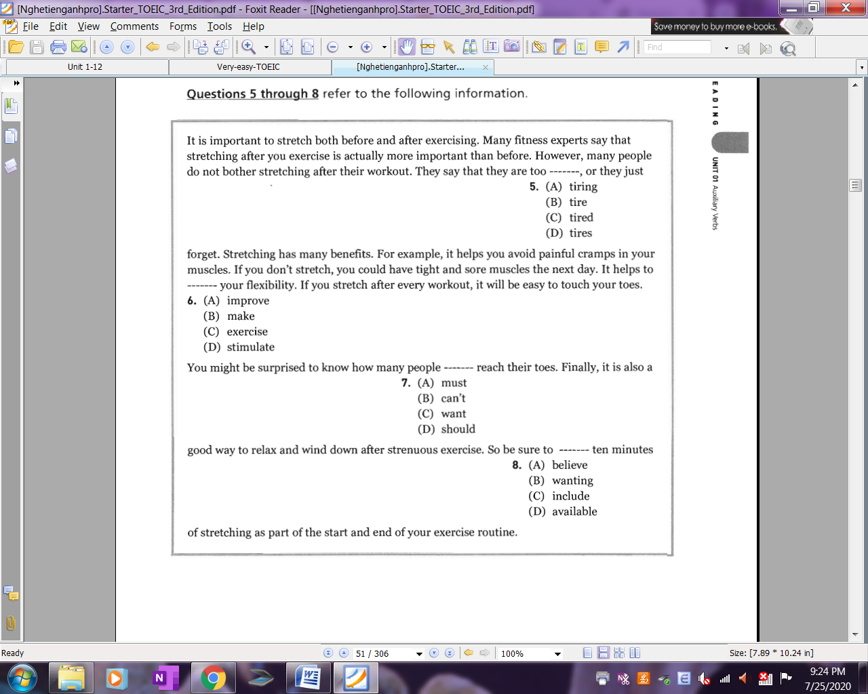
45.
46.
44.
43.

Questions 47 through 50 refer to the following information.
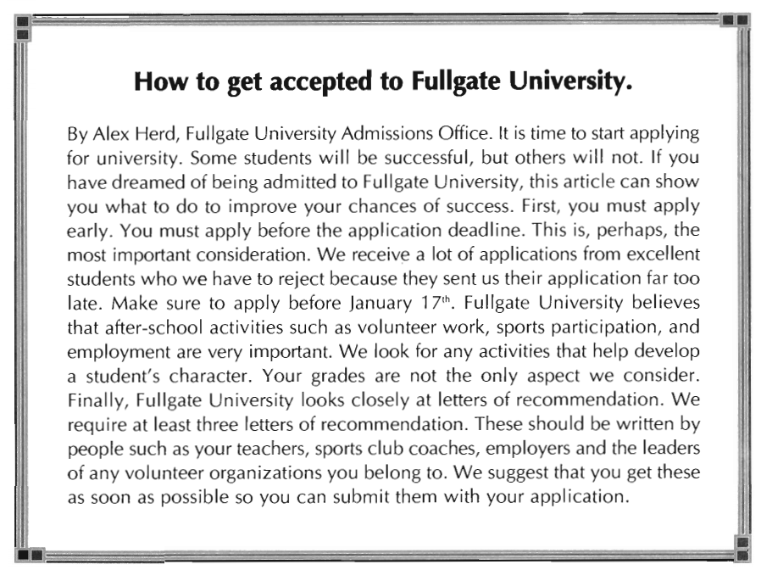
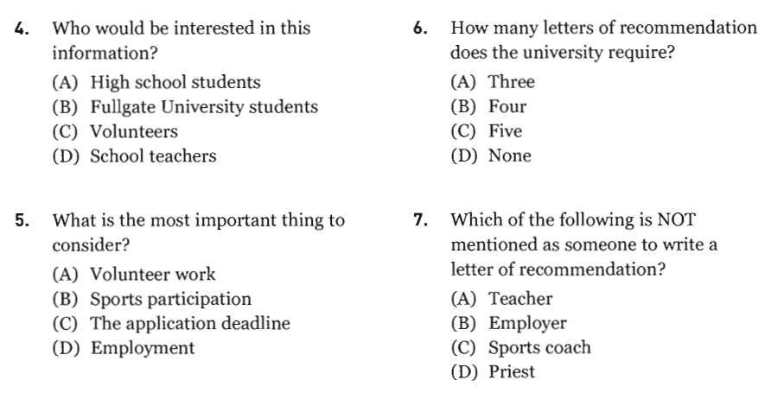
50.
49.
48.
47.
_______Hết_______

GHI CHÚ: CÁN BỘ COI THI KHÔNG ĐƯỢC GIẢI THÍCH GÌ THÊM.

TRƯỞNG KHOA TRƯỞNG BỘ MÔN GIẢNG VIÊN RA ĐỀ
(Ký tên và ghi rõ họ tên) (Ký tên và ghi rõ họ tên) (Ký tên và ghi rõ họ tên)

UBND THÀNH PHỐ HỒ CHÍ MINH | CỘNG HÒA XÃ HỘI CHỦ NGHĨA VIỆT NAM
TRƯỜNG CAO ĐẲNG LÝ TỰ TRỌNG | Độc lập - Tự do - Hạnh phúc
THÀNH PHỐ HỒ CHÍ MINH
ĐỀ THI KẾT THÚC HỌC PHẦN LÝ THUYẾT
HỌC KỲ: II NĂM HỌC: 2019 – 2020
Bậc đào tạo: CAO ĐẲNG (C1)
Học phần: TIẾNG ANH 1
Lớp: 19C1-_________ Ngày thi: _______ / _______ / 2020
Thời gian thi: 60 phút (không kể thời gian phát đề)

Thí sinh không được sử dụng tài liệu, nộp lại đề sau khi thi
Mã đề 105

Bài thi này gồm 50 câu, mỗi câu 0.2 điểm.

Multiple-choice
1/ I usually ___ up at 7:00 in the morning.
a got b get c getting d gets
1/ The sofa is in the ___.
a wall b floor c two chairs d corner
2/ The chairs are next to the big table in the ___.
a office b dining room c staff d Both a&b are correct.
3/ Our office has a green sofa in the ___.
a mirror b bathroom c bedroom d waiting room
4/ There are keys ___ the bowl ___ to the lamp.
a on/ next b in/ next c in/ on d on/ front
5/ I'm late ___ work.
a for b on c in d at
6/ She ___ her keys on the table.
a make b lock c take d put
7/ There ___ a bedroom.
a isn't b is any c are d All are correct.
8/ I bought an apple at the ____.
a supermarket b cupboard c library d kitchen
9/ They went shopping ___ Sunday.
a on b in c at d to
10/ They went to the gym ___ work yesterday.
a in b before c about d on
11/ - ___ Emily go to college? - No. She ___ to school.
a Do/ go b Does/ go c Was/ went d Did/ went
12/ Austrians work ___ hours than people in other countries.
a much b fewer c less d least
13/ An Austrian ___ works 1,330 hours a year, around 25 hours a week.
a employee b employment c employers d employees
14/ 1 ___4 Americans don't get any paid time off of work.
a on b to c in d at
15/ Vacations help workers perform ___ at work.
a fewer b badder c better d All are correct.
16/ She did some ____ at home yesterday.
a average b choice c vacation d errands
17/ We also need a ___ of tomato sauce for the pasta.
a jar b bottle c carton d Both a&b are correct.
18/ We need two ___ tomatoes for the sauce.
a some b more c few d Both a&b are correct.
19/ Can I buy a ___ of ___?
a box/ cookie b box/ cookies c boxes/ cookies d Both a&b are correct.
20/ ___ sandwiches were called sandwiches, they had been eaten.
a Although b Despite c Because d Before
21/ I didn't ____an egg for breakfast.
a had b ate c have d Both a&c are correct.
22/ ___ the winter, the church is open.
a On b In c At d To
23/ Choose the word that is different.
a mushrooms b carrots c strawberries d tomatoes
24/ How many ____ of ____can you sell a day?
a boxes/ cookie b boxes/ cookies c box/ cookies d Both a&b are correct.
25/ Mary, my ____, lives in a big city far away from us.
a nephew b grandfather c uncle d aunt
26/ Hector's ___ are John and Sara.
a parents b sons c nephews d daughters
27/ Your father's son is your ___.
a nephew b brother c son d Both a&c are correct.
28/ Your grandfather's daughter is your ___.
a aunt b sister c mother d Both a&c are correct.
29/ I have a brother. ___ brother is a doctor.
a Her b Your c His d My
30/ Jenny has a house in the city. ___ house is very big.
a Her b His c My d Our
31/ He works near his ____ office.
a wifes b wife's c wifes' d wife
32/ Niger and Liberia have a(n)___of 4 to 7 children per family.
a division b average c account d action
33/ The baby has been ___ all day.
a cried b cry c crying d to cry
34/ What ___ you ___ at school tomorrow?
a do/ study b do/ studying c are/ studying d Both a&c are correct.
35/ He has a(n) ___ this afternoon with his dentist.
a arrange b promises c punish d appointment
36/ He had been to Oxford twice ____ I went there.
a since b after c already d before
37/ He didn’t go shopping because he ___ sick.
a did be b were c is d was
38/ When I arrived at my aunt’s home, she ___ her kitchen floor.
a was sweeping b sweep c had sweeping d sweeps
39/ We ___ having more cookies. They're delicious!
a look forward b can stand c get up d can’t help
40/ It began ___.
a raining b rain c to rain d Both a&c are correct.
41/ I like ___ a bike.
a riding b to ride c ride d Both a&b are correct.
42/ The manager ___ us to return the DVD before noon today.
a likes b would like c like d is liking

Questions 43 through 46 refer to the following information.
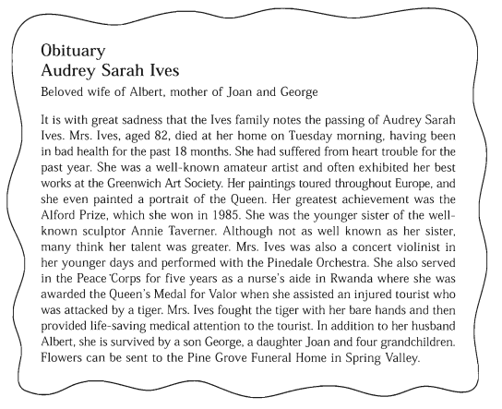
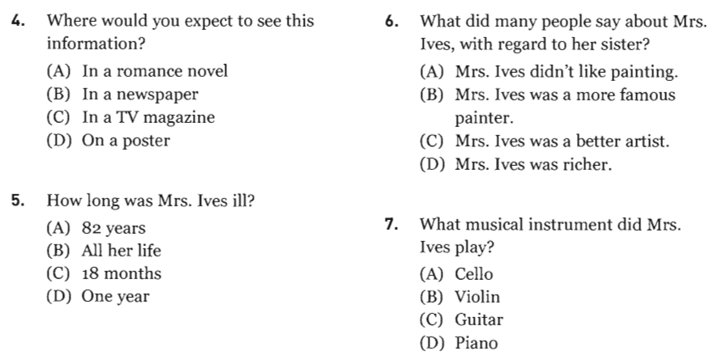
46.
45.
44.
43.
Questions 47 through 50 refer to the following chart.
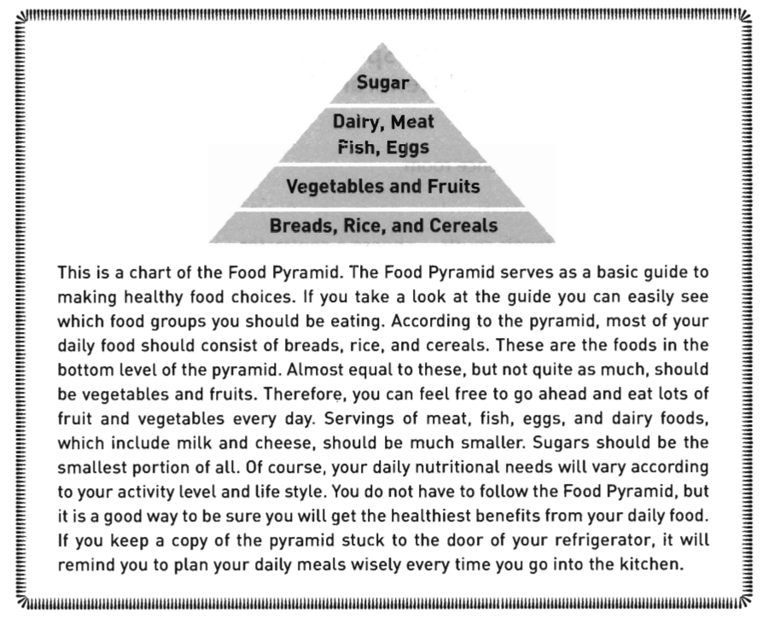
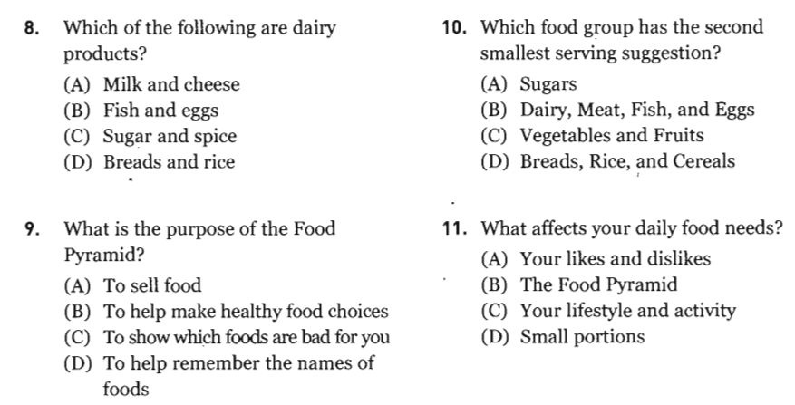
48.
50.
49.
47.
_______Hết_______

GHI CHÚ: CÁN BỘ COI THI KHÔNG ĐƯỢC GIẢI THÍCH GÌ THÊM.

TRƯỞNG KHOA TRƯỞNG BỘ MÔN GIẢNG VIÊN RA ĐỀ
(Ký tên và ghi rõ họ tên) (Ký tên và ghi rõ họ tên) (Ký tên và ghi rõ họ tên)

UBND THÀNH PHỐ HỒ CHÍ MINH | CỘNG HÒA XÃ HỘI CHỦ NGHĨA VIỆT NAM
TRƯỜNG CAO ĐẲNG LÝ TỰ TRỌNG | Độc lập - Tự do - Hạnh phúc
THÀNH PHỐ HỒ CHÍ MINH
ĐỀ THI KẾT THÚC HỌC PHẦN LÝ THUYẾT
HỌC KỲ: II NĂM HỌC: 2019 – 2020

Bậc đào tạo: CAO ĐẲNG (C1)
Học phần: TIẾNG ANH 1
Lớp: 19C1-_________ Ngày thi: _______ / _______ / 2020
Thời gian thi: 60 phút (không kể thời gian phát đề)

Thí sinh không được sử dụng tài liệu, nộp lại đề sau khi thi
Mã đề 106

Bài thi này gồm 50 câu, mỗi câu 0.2 điểm.

Multiple-choice
1/ Your wife's mother is your ___.
a mother b mother-in-law c aunt d grandmother
2/ Your father's son is your ___.
a brother b son c nephew d Both a&c are correct.
3/ - How ___? - I'm twenty.
a old you are b are you c you are old d old are you
4/ Jenny has a house in the city. ___ house is very big.
a His b Our c Her d My
5/ He works near his ____ office.
a wifes' b wife c wifes d wife's
6/ Choose the word that is different.
a twelfth b seven c first d third
7/ My sister is ____.
a affected b addible c adopted d adapted
8/ I ___ sharing a room.
a hate b am having c want d have
9/ There ___ a large bed, and there ____ some big cupboards.
a was/ were b was/ was c were/ were d were/ was
10/ What do you always do first ___ you come home?
a what b while c because d when
11/ She ___ her keys on the table.
a take b lock c put d make
12/ I ___ the door and come inside.
a unlock b clock c unclock d All are correct.
13/ I'm interested ____ the apartments ___ rent.
a in/ for b to/ to c to/ in d at/ for
14/ There's a couch ___ the lamp ___ the table.
a between/ of b next to/ in c on/ on d between/ and
15/ They bought ___ land and built a tiny house on it.
a a piece of b small c some d Both a&c are correct.
16/ There ____ sugar in my tea.
a is any b is a c isn't any d isn't a
17/ We have lived here ___ twenty years.
a ago b for c since d Both a&b are correct.
18/ John ___ the movie twice.
a saw b sees c has seen d have seen
19/ She ___ at 123 Main Street.
a living b lives c live d Both a&b are correct.
20/ Mina ___ French for ten years.
a studies b studied c has studied d Both a&b are correct.
21/ I’ve ___ the book already.
a reading b been read c read d will read
22/ He has a(n) ___ this afternoon with his dentist.
a appointment b arrange c punish d promises
23/ When I arrived at my aunt’s home, she ___ her kitchen floor.
a sweep b was sweeping c had sweeping d sweeps
24/ Joseph told me he ___ his project.
a already finished b had already finishing
c finishing d had already finished
25/ Please ___ me to stretch before I exercise.
a minded b reminded c remind d mind
26/ The actress was tired of ___ autographs.
a signing b signature c sign d signs
27/ I ___ a movie last week with my family.
a saw b see c look d watch
28/ Where did you ____ a movie?
a go b went c see d saw
29/ How ___ hours a week do you think people should work?
a about b many c much d any
30/ Should ____ give workers vacation time?
a employers b employees c employer d employments
31/ Austrians work ___ hours than people in other countries.
a much b fewer c less d least
32/ You should consider moving to a country with ____.
a a good vacation time policy b lots of requirements
c fewer working hours d Both a&c are correct.
33/ She did some ____ at home yesterday.
a vacation b average c choice d errands
34/ What ___ the weather ___ yesterday?
a was/ like b did/ like c was/ liked d did/ liked
35/ We also need a ___ of tomato sauce for the pasta.
a jar b bottle c carton d Both a&b are correct.
36/ Would you like to add ___ salt to the soup?
a any b some c a few d Both a&b are correct.
37/ The bread held meats, cheeses, and was sometimes covered ___ gravy.
a at b to c in d over
38/ There _____ cheese in the refrigerator.
a are any b are some c is some d is any
39/ ___ the winter, the church is open.
a To b At c In d On
40/ Choose the word that is different.
a bananas b pineapples c strawberries d cookies
41/ Nacho didn't have salad ____ lunch.
a for b in c to d All are correct.
42/ - How ___ do you add salt to your food? - Sometimes.
a much b often c many d long

Questions 43 through 46 refer to the following memo.
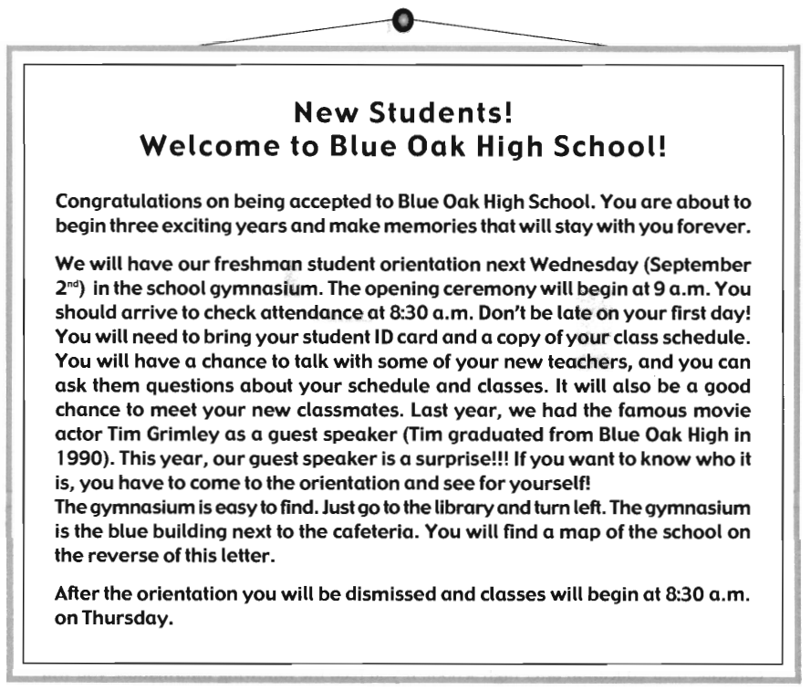
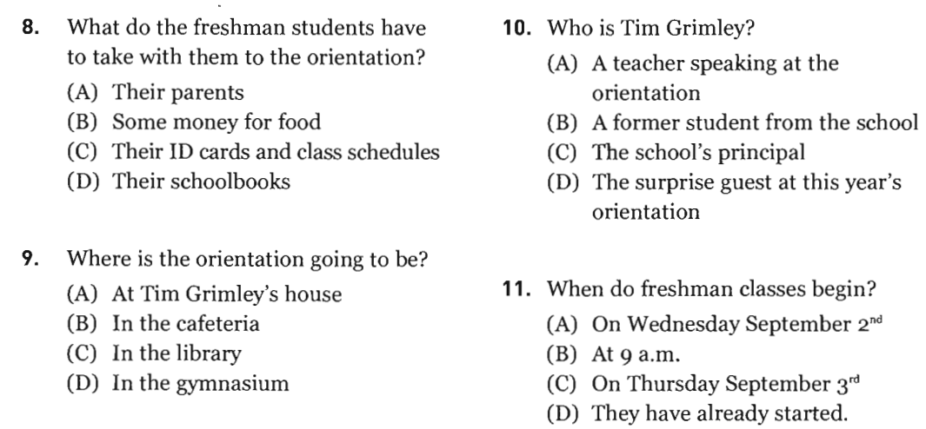
46.
45.
44.
43.

Questions 47 through 50 refer to the following notice.
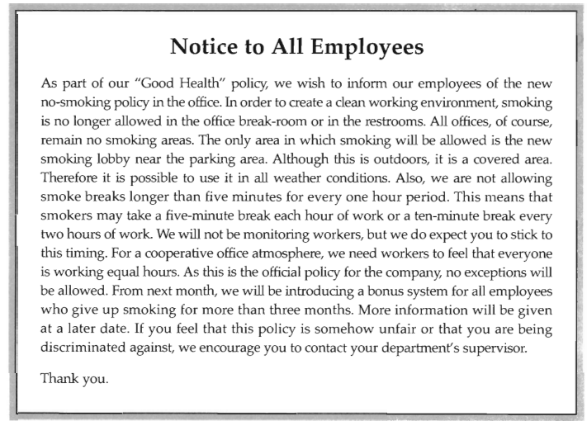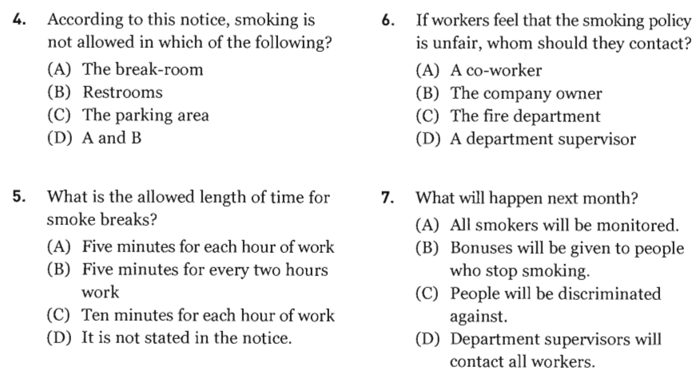
50.
49.
48.
47.

_______Hết_______

GHI CHÚ: CÁN BỘ COI THI KHÔNG ĐƯỢC GIẢI THÍCH GÌ THÊM.

TRƯỞNG KHOA TRƯỞNG BỘ MÔN GIẢNG VIÊN RA ĐỀ
(Ký tên và ghi rõ họ tên) (Ký tên và ghi rõ họ tên) (Ký tên và ghi rõ họ tên)

UBND THÀNH PHỐ HỒ CHÍ MINH | CỘNG HÒA XÃ HỘI CHỦ NGHĨA VIỆT NAM
TRƯỜNG CAO ĐẲNG LÝ TỰ TRỌNG | Độc lập - Tự do - Hạnh phúc
THÀNH PHỐ HỒ CHÍ MINH
ĐÁP ÁN ĐỀ THI KẾT THÚC HỌC PHẦN LÝ THUYẾT
HỌC KỲ: II NĂM HỌC: 2019 – 2020
Bậc đào tạo: CAO ĐẲNG (C1)
Học phần: TIẾNG ANH 1
Lớp: 19C1-_________ Ngày thi: _______ / _______ / 2020
Thời gian thi: 60 phút (không kể thời gian phát đề)

NỘI DUNG

Câu số | Mã đề thi
Câu số | 101 | 102 | 103 | 104 | 105 | 106
1
2
3
4
5
6
7
8
9
10
11
12
13
14
15
16
17
18
19
20
21
22
23
24
25
26
27
28
29
30
31
32
33
34

Câu số | Mã đề thi
Câu số | 101 | 102 | 103 | 104 | 105 | 106
35
36
37
38
39
40
41
42
43 | C | C | C | C | B | C
44 | C | B | C | A | C | D
45 | B | B | B | B | C | B
46 | B | C | A | C | B | C
47 | C | D | C | A | A | D
48 | A | D | C | C | B | A
49 | C | B | D | A | B | D
50 | B | A | C | D | C | B

_______Hết_______

TRƯỞNG BỘ MÔN GIẢNG VIÊN RA ĐỀ
(Ký và ghi rõ họ tên) (Ký và ghi rõ họ tên)

¤ Đáp án của đề thi 1:
1[ 1]c... 2[ 1]b... 3[ 1]b... 4[ 1]a... 5[ 1]d... 6[ 1]a... 7[ 1]a... 8[ 1]b...
9[ 1]c... 10[ 1]b... 11[ 1]a... 12[ 1]d... 13[ 1]d... 14[ 1]c... 15[ 1]a... 16[ 1]a...
17[ 1]c... 18[ 1]c... 19[ 1]b... 20[ 1]d... 21[ 1]d... 22[ 1]a... 23[ 1]d... 24[ 1]d...
25[ 1]c... 26[ 1]a... 27[ 1]d... 28[ 1]d... 29[ 1]a... 30[ 1]b... 31[ 1]b... 32[ 1]b...
33[ 1]d... 34[ 1]a... 35[ 1]b... 36[ 1]d... 37[ 1]b... 38[ 1]b... 39[ 1]d... 40[ 1]a...
41[ 1]d... 42[ 1]b...

¤ Đáp án của đề thi 2:
1[ 1]a... 2[ 1]d... 3[ 1]c... 4[ 1]b... 5[ 1]c... 6[ 1]d... 7[ 1]c... 8[ 1]a...
9[ 1]b... 10[ 1]d... 11[ 1]b... 12[ 1]d... 13[ 1]a... 14[ 1]b... 15[ 1]d... 16[ 1]d...
17[ 1]b... 18[ 1]d... 19[ 1]d... 20[ 1]c... 21[ 1]c... 22[ 1]b... 23[ 1]d... 24[ 1]d...
25[ 1]c... 26[ 1]b... 27[ 1]a... 28[ 1]c... 29[ 1]d... 30[ 1]d... 31[ 1]a... 32[ 1]c...
33[ 1]c... 34[ 1]a... 35[ 1]c... 36[ 1]b... 37[ 1]c... 38[ 1]a... 39[ 1]b... 40[ 1]d...
41[ 1]a... 42[ 1]d...

¤ Đáp án của đề thi 3:
1[ 1]b... 2[ 1]d... 3[ 1]b... 4[ 1]d... 5[ 1]d... 6[ 1]d... 7[ 1]b... 8[ 1]c...
9[ 1]d... 10[ 1]b... 11[ 1]d... 12[ 1]b... 13[ 1]b... 14[ 1]a... 15[ 1]c... 16[ 1]c...
17[ 1]d... 18[ 1]b... 19[ 1]b... 20[ 1]a... 21[ 1]d... 22[ 1]a... 23[ 1]d... 24[ 1]b...
25[ 1]a... 26[ 1]b... 27[ 1]b... 28[ 1]d... 29[ 1]a... 30[ 1]a... 31[ 1]b... 32[ 1]b...
33[ 1]d... 34[ 1]a... 35[ 1]d... 36[ 1]d... 37[ 1]a... 38[ 1]b... 39[ 1]a... 40[ 1]b...
41[ 1]d... 42[ 1]c...

¤ Đáp án của đề thi 4:
1[ 1]b... 2[ 1]a... 3[ 1]b... 4[ 1]d... 5[ 1]c... 6[ 1]d... 7[ 1]a... 8[ 1]b...
9[ 1]a... 10[ 1]d... 11[ 1]c... 12[ 1]d... 13[ 1]b... 14[ 1]d... 15[ 1]a... 16[ 1]d...
17[ 1]d... 18[ 1]a... 19[ 1]a... 20[ 1]a... 21[ 1]d... 22[ 1]a... 23[ 1]b... 24[ 1]a...
25[ 1]a... 26[ 1]a... 27[ 1]d... 28[ 1]a... 29[ 1]b... 30[ 1]b... 31[ 1]b... 32[ 1]b...
33[ 1]b... 34[ 1]c... 35[ 1]d... 36[ 1]c... 37[ 1]d... 38[ 1]b... 39[ 1]d... 40[ 1]a...
41[ 1]b... 42[ 1]a...

¤ Đáp án của đề thi 5:
1[ 1]d... 2[ 1]d... 3[ 1]d... 4[ 1]b... 5[ 1]a... 6[ 1]d... 7[ 1]a... 8[ 1]a...
9[ 1]a... 10[ 1]b... 11[ 1]d... 12[ 1]b... 13[ 1]a... 14[ 1]c... 15[ 1]c... 16[ 1]d...
17[ 1]d... 18[ 1]b... 19[ 1]b... 20[ 1]d... 21[ 1]c... 22[ 1]b... 23[ 1]c... 24[ 1]b...
25[ 1]d... 26[ 1]a... 27[ 1]b... 28[ 1]d... 29[ 1]d... 30[ 1]a... 31[ 1]b... 32[ 1]b...
33[ 1]c... 34[ 1]d... 35[ 1]d... 36[ 1]d... 37[ 1]d... 38[ 1]a... 39[ 1]d... 40[ 1]d...
41[ 1]d... 42[ 1]b...

¤ Đáp án của đề thi 6:
1[ 1]b... 2[ 1]a... 3[ 1]d... 4[ 1]c... 5[ 1]d... 6[ 1]b... 7[ 1]c... 8[ 1]a...
9[ 1]a... 10[ 1]d... 11[ 1]c... 12[ 1]a... 13[ 1]a... 14[ 1]d... 15[ 1]d... 16[ 1]c...
17[ 1]b... 18[ 1]c... 19[ 1]b... 20[ 1]c... 21[ 1]c... 22[ 1]a... 23[ 1]b... 24[ 1]d...
25[ 1]c... 26[ 1]a... 27[ 1]a... 28[ 1]c... 29[ 1]b... 30[ 1]a... 31[ 1]b... 32[ 1]d...
33[ 1]d... 34[ 1]a... 35[ 1]d... 36[ 1]b... 37[ 1]c... 38[ 1]c... 39[ 1]c... 40[ 1]d...
41[ 1]a... 42[ 1]b...

